I-20 Request Form
Your Form I-20 will be issued only AFTER you have been accepted and offered enrollment, you have paid the required deposit, AND the school has verified all documents, including a copy of your passport ID page and sponsor financial documents.
PURPOSE OF REQUEST  New Form I-20  I-20 Transfer from your current/most recent U.S. school
STUDENT INFORMATION Passport Number:__________________ Issuing Country:_________________________
Student’s name EXACTLY as it appears on passport: _______________________________________________________
(Last) (First) (Middle)
Student’s sex as it appears on passport: Male Female _____ Date of Birth _______ _______ _______
(Month) (Day) (Year)
Place of Birth:__________________ ___________________ Country of Citizenship:__________________________
(City) (Country)
Permanent address in your country of residence: __________________________________________________________________________________________________
__________________________________________________________________________________________________
Phone: __________________________
During the pandemic, SEVP allows your Form I-20 to be sent by email. You must print and sign it and bring it to your visa appointment, and you must also present it every time you enter the United States on your F-1 visa. Federal law requires that it be addressed to the student only and not to a relative or agent.
Student’s email address:___________________________
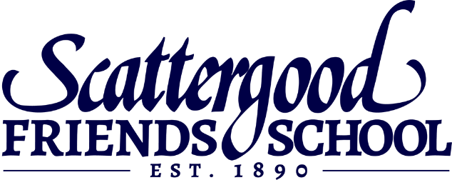
**************************************************************************************************If you are already in the United States, or already have a US visa, what is your current status?  F-1 non-immigrant student
❑ Another status: _______________________________________
Your SEVIS ID Number: N_________________________________
**************************************************************************************************
Provide COPIES of documents to: (Keep your ORIGINAL documents for your visa interview.) PDSO, Scattergood Friends School
Email: ataylor@scattergood.org
Fax: +1 (319) 643-7485
Mail: 1951 Delta Avenue
West Branch, IA 52358 USA

Estimated Cost of Attendance (E.C.A.)
To qualify for a Form I-20 and successfully apply for your F-1 Student Visa, your sponsors must promise to provide you sufficient financial support for every year of your program AND they must submit financial documents to prove that they have the income or assets to do so, while continuing to support themselves and their dependents.
2022-23 Full Tuition (including room & board)* $42,000
Suggested Living Expenses** 1,500 Health Insurance*** 1,750 Total Estimated Cost of Attendance (per year) $45,250
*TUITION: Your actual tuition amount may be lower if you are awarded financial aid or scholarships. This amount includes your room and all meals while school is in session.
**SUGGESTED LIVING EXPENSES: This represents an extremely modest average budget. Examples of expenses that are NOT included in tuition and are the responsibility of the student/sponsor include: health care costs not covered by insurance, college application and test fees, bedding and clothing, personal care items, optional month-long May Term trips, etc. You and your family should closely consider the costs of living and studying at Scattergood and make careful plans to be sure your needs will be met.
***HEALTH INSURANCE: Students are REQUIRED to purchase their own private health insurance before arriving on campus. $1,750 is the estimated annual cost, but the ultimate cost may be more or less depending on the company and plan you select. Contact Scattergood’s business office for more information about selecting a health insurance plan.
FREQUENTLY ASKED QUESTIONS ABOUT THE E.C.A. AND FINANCIAL SUPPORT:
How much financial support do I need to qualify for a form I-20? Once your tuition amount is set by the business office, you can calculate your E.C.A. This is the amount of liquid discretionary funding (financial capability that exceeds the cost of living in your country) you or your sponsors need to prove.
2022-23 tuition (after any aid/scholarship) $___________
Suggested Living Expenses + 1,500 Health Insurance + 1,750 Total Estimated Cost of Attendance (per year) = $ ___________
Are there employment opportunities for students? No. Scattergood is a secondary school and therefore does not provide on-campus employment opportunities for students. Additionally, students are not allowed to work off-campus.

Financial Evidence Requirements
Proof of sufficient financial support is a requirement of the U.S. Department of Homeland Security’s (DHS) Student and Exchange Visitors Program (SEVP). You will also need to bring this financial proof to your visa appointment. After we receive the documents and affidavit(s), we will calculate whether your sponsors can afford to pay the amount they have promised without becoming impoverished. To do this, we use a formula that considers the number of dependents that your sponsor is supporting and your country’s GDP. For this reason, a sponsor needs to show that they have MORE income/assets than is needed to financially support the student (a bank account showing the exact amount of support needed is NOT considered sufficient proof). Scattergood’s Primary Designated SEVIS Official (PDSO) or Director of Admissions will request additional sponsors or proof of income/assets if needed
YOUR FUNDING CAN COME FROM ANY COMBINATION OF THESE SOURCES:
- FUNDS FROM “SPONSORS” (parents, relatives, friends, organizations, companies)
- A sponsor should promise only as much money as they are capable of providing to you. That is, only what they intend to provide and only as much as can be afforded. It is highly recommended that at least part of your financial support comes from your home country. This may contribute to the success of your student visa application.
- Each sponsor should submit 1.) a Sponsor’s Financial Affidavit, 2.) proof of income (a recent pay stub, income tax receipts, or three months of bank statements showing regular salary/income deposits), and 3.) proof of liquid funds (three months of recent bank statements). If more than one person’s name appears on the bank statement, each of those persons must submit a Sponsor Affidavit.
- Depending on your financial situation, you may have more than one sponsor. Each one should provide financial documents and the Sponsor’s Financial Affidavit.
- PERSONAL FUNDS – A bank account in the student’s name only or a passive income source is less common for high school students. Your parent or legal guardian should co-sign the Sponsor’s Financial Affidavit if you are under age 18.
- FUNDS FROM SCATTERGOOD in the form of financial aid and scholarships. Because financial aid is re-assessed each year and is only guaranteed for one year and not for your entire program of study, you may need additional support to meet your minimum annual costs. Be sure to bring a copy of your tuition contract to your visa appointment.

Explanation of Sponsor’s Financial Affidavit
GIVE THESE INSTRUCTIONS TO THE PERSON(S) WHO WILL PAY FOR YOUR TUITION AND LIVING EXPENSES.
The United States government requires each student prove that they and/or their sponsors will be able to meet the costs of tuition and living expenses. The school is required to examine this proof before issuing the student their Form I-20 and this proof will also be essential for the student to successfully apply for a F-1 student visa.
By completing this affidavit (written promise), you are promising that you will provide this student with a specific amount of money, from your own financial resources, for every year he or she will study at Scattergood Friends School. The financial documents you provide will prove that you can fulfil this promise without becoming impoverished.
HOW TO COMPLETE THE SPONSOR’S FINANCIAL AFFIDAVIT FORM:
- Fill out the Sponsor’s Financial Affidavit. Promise only the amount of money you are able to give. Be sure to sign and date the form.
- Attach the supporting evidence listed below. The affidavit will not be accepted without the required supporting evidence.
- Give the student the original documents. The student will submit them by email or make photocopies to mail or fax to us. The student will keep the original documents which are required for the F-1 student visa interview.
ATTACH THE FOLLOWING SUPPORTING EVIDENCE:
If you are a parent, relative, friend, or other individual:
- Proof of Income such as your most recent pay stub, income tax returns/receipts, or three months of bank statements showing regular deposits.
- Proof of Liquid Funds such as three months of bank statements, either in USD or another currency that is clearly noted, in English if possible. Do not submit a letter from a bank officer. Note: If another person’s name (spouse, business partner, etc.) appears on your bank statement, that person must also complete a Sponsor’s Financial Affidavit Form.
If you are a company or organization:
- An official company letter less than two months old, that states the name of the student and the amount of annual support, and
- Business registration and/or licenses, and
- A profit and loss statement less than two months old. (Do not submit a letter from a bank officer.)

Sponsor’s Financial Affidavit Form
(Promise of Financial Support)
I, ________________________________________________________________, promise that I CAN and WILL provide
(Sponsor’s Full Name – PRINT LEGIBLY)
____________________________________________ no less than USD$___________________________________
(Student’s Full Name)
for EVERY YEAR of the student’s program of study at Scattergood Friends School.
My relation to the student is: ____________________________________________________________
(Parent, brother/sister, aunt/uncle, friend, etc.)
My address: _________________________________________ My phone: ___________________________
_________________________________________ My email: ___________________________
_________________________________________
These persons are fully or partially dependent upon me for their support (do not include the student named above):
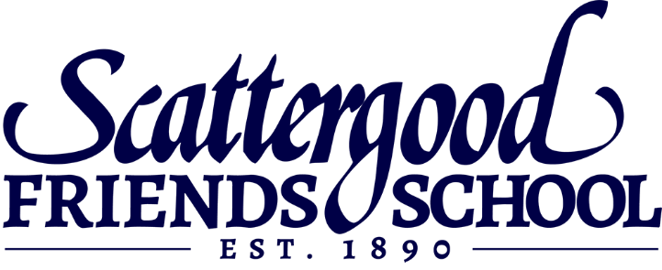
_________________________________________________________________________________________________
(Name) (Relationship to me) (Age)
_________________________________________________________________________________________________
(Name) (Relationship to me) (Age)
_________________________________________________________________________________________________
(Name) (Relationship to me) (Age)
_________________________________________________________________________________________________
(Name) (Relationship to me) (Age)
Name of my employer: __________________________________ My job title:_________________________________
My Annual Salary in USD: $_______________________ Other Annual Income in USD: $________________________
>> I will email or fax documents (see previous page) that show my income and/or assets.  Yes  No
>> I understand that failure to pay tuition and fees as agreed will result in the student being disenrolled and therefore out of compliance with F-1 visa status. A disenrolled student is unable to enter the United States (if not already present) and is required to depart the United States shortly after their last day of attendance.  Yes  No
____________________________________________________________ ____________________________
SIGNATURE OF SPONSOR DATE SIGNED
Send COPIES of all documents to:
PDSO, Scattergood Friends School
Email: ataylor@scattergood.org
Fax: +1 (319) 643-7485
KEEP ALL ORIGINAL DOCUMENTS
FOR YOUR VISA APPOINTMENT

